**.**



**KABARAK UNVERSITY**

**SCHOOL OF SCIENCE ENGINEERING AND TECHNOLOGY**

**DEPARTMENT OF COMPUTER SCIENCE AND IT**

**PROJECT PROPOSAL**

**PROJECT PROPOSAL TITLE: QR- BASED FOOD ORDERING AND PAYMENT SYSTEMS**

**A project Report Documentation submitted to The Department of Computer Science and IT in partial fulfillment of the degree of computer science.**

**SUBMITTED BY**

**NAME: LEVIN HAVWI**

**INTE/MG/1825/09/20**

**SUPERVISOR: MR MOCHOGE**

# **DEDICATION**

I wish to dedicate this work to all the counterparts who have helped me throughout the period of writing this proposal.

# **ACKNOWLEDGEMENTS**

I would like to express my heartfelt gratitude to all those who have contributed to the development of this project proposal. I extend my thanks to my supervisor, MR. Mochoge, for his guidance and valuable insights throughout the research process.

I would also like to acknowledge the contributions of my colleagues and friends who provided me with valuable feedback and support during this endeavor.

# **DECLARATION**

I hereby declare that all information in this document has been obtained and presented in accordance with academic rules and ethical conduct. I also declare that, as required by these rules and conduct, I have fully written this report based on truth and cited all activities and duties that I undertook while writing the project proposal. I therefore declare that this material is original.

NAME: **LEVIN HAVWI**

REG.NUMBER: INTE/MG/1825/09/20

Signature..................................................

Date.....................................

**Declaration by lecturer**

NAME: **CLEOPHAS MOCHOGE**

This work was submitted with my approval.

Signature……………….

Date…………………….

Contents

**DEDICATION** 2

**ACKNOWLEDGEMENTS** 3

**DECLARATION** 4

**ABSTRACT** 5

**CHAPTER ONE** 6

**1.0 INTRODUCTION** 6

**1.1 BACKGROUND OF THE STUDY** 6

**1.2 STATEMENT OF THE PROBLEM** 7

**1.3 PURPOSE OF THE STUDY** 7

**1.4 OBJECTIVES** 7

**1.4.1 Main objective** 7

**1.4.1 Specific Objectives** 7

**1.5 JUSTIFICATION** 7

**1.6 RESEARCH QUESTIONS** 8

**1.7 SIGNIFICANCE OF THE STUDY** 8

**1.8 SCOPE AND LIMITATIONS OF THE STUDY** 8

**CHAPTER TWO** 10

**2.0 LITERATURE REVIEW** 10

**2.1 INTRODUCTION** 10

**2.2 REVIEW OF RELATED LITERATURE** 10

**2.2.1 Optimized order management and streamlined kitchen operations, ensuring timely and accurate food preparation.** 10

**2.2.2 Created a user-friendly mobile app and web interface that generated unique QR codes for each table or guest.** 11

**2.2.3 Implemented efficient payment processing capabilities within the system.** 12

**2.3 THEORETICAL FRAMEWORK** 12

**2.4 IDENTIFICATION OF KNOWLEDGE GAP** 13

**2.4.1 Contextual Generalization** 13

**2.4.2 Detailed Examination of User Experience** 13

**2.4.3 Understanding Trust and Attitude** 13

**2.4.4 Clarification of Moderating Factors** 14

**2.4.5 Integration of Emerging Technologies** 14

**2.4.6 Consideration of User Demographics** 14

**CHAPTER THREE** 15

**3.0 RESEARCH METHODOLOGY** 15

**3.1 INTRODUCTION** 15

**3.2 RESEARCH DESIGN** 15

**3.1.1 Rationale for Mixed-Methods Design** 15

**3.1.2 Flexibility and Adaptability** 15

**3.1.3 Data Integration** 16

**3.1.4 Triangulation of Results** 16

**3.3 LOCATION OF THE STUDY** 16

**3.4 TARGET POPULATION** 17

**3.5 SAMPLE AND SAMPLING PROCEDURES** 17

**3.5.1 Consumer Sampling** 17

**3.5.2 Establishment Sampling** 18

**3.5.3 Sample Size Determination** 18

**3.5.4 Recruitment Strategies** 18

**3.5.5 Informed Consent** 18

**3.6 DATA COLLECTION INSTRUMENTS** 19

**3.6.1 Validity** 19

**3.6.2 Reliability** 19

**3.7 DATA COLLECTION PROCEDURES** 20

**3.7.1 Quantitative Data Collection** 20

**3.7.2 Qualitative Data Collection** 20

**3.8 DATA ANALYSIS AND PRESENTATION** 21

**3.8.1 Context Diagram** 23

**3.8.2 Use-case Diagram** 24

**3.8.3 Dataflow Diagram** 25

**3.9 ETHICAL ISSUES AND ETHICAL CONSIDERATIONS** 26

**REFERENCES** 27

**APPENDICES** 28

**TABLE 1: WORKPLAN** 28

**TABLE 2: BUDGET** 28

**INSTRUMENTS** 29

QUESTIONNAIRRE 29

**INTERVIEWS** 31

**TABLE OF FIGURES**

Figure 1: CONTEXT DIAGRAM 26

Figure 2:USE-CASE DIAGRAM 27

*Figure 3: DATA FLOW DIAGRAMS* 28

Figure 4:QUESTIONNAIRE 32

Figure 5:QUESTONNAIRE 2 33

**LIST OF FIGURES**

Table 1:WORKPLAN 31

Table 2:BUDGET 31

# **ABSTRACT**

Traditional food ordering in hotels often involved time-consuming, in-person interactions or phone orders, leading to inconveniences for both guests and staff, compounded by delays in end-of-meal payments. This proposal introduced a comprehensive solution: a QR code-based food ordering and payment system designed to streamline the dining experience. The primary objective of this project was to seamlessly integrate QR codes into the food ordering process through a user-friendly mobile app or web interface, generating unique QR codes for each table or guest. This innovation bridged the gap between traditional dining and digital convenience, expediting orders while affording guests the flexibility to peruse menus, customize selections, and cater to specific dietary needs. With a key focus on secure payment processing within the app, accommodating diverse methods such as credit/debit cards, mobile wallets, and emerging digital currencies, the system eliminated long queues and enhanced overall service efficiency. Furthermore, the project included order management features, like kitchen notifications and order tracking, ensuring timely, accurate service. Prioritizing user experience, the system emphasized an intuitive, user-friendly interface for guests of all tech-savviness levels, aiming for a smooth and enjoyable ordering process. Data security remained paramount, with the system adhering to data privacy regulations to protect guest data, payment information, and order history. To ensure a seamless transition and successful implementation, comprehensive training programs for hotel and restaurant staff were integral, equipping them to assist guests with the system and handle potential technical issues. In conclusion, the QR code-based food ordering and payment system showed promise in improving the dining experience for guests and streamlining operations for establishments, addressing challenges associated with ordering, payment processing, and order management. It offered a comprehensive framework for modernizing food orders and payments while enhancing customer satisfaction and service quality in the hospitality industry.

# **CHAPTER ONE**

# **1.0 INTRODUCTION**

The hospitality industry underwent a paradigm shift, driven by technological advancements. This chapter introduced a project focused on addressing challenges in this evolving landscape through the development of a novel system. The project aimed to enhance efficiency, streamline operations, and improve the overall experience for both customers and establishments.

# **1.1 BACKGROUND OF THE STUDY**

In the dynamic landscape of the hospitality industry, conventional methods of food ordering and payment within hotels became increasingly inadequate, marked by time-consuming interactions and manual order placements. The limitations of these traditional approaches led to inefficiencies and suboptimal experiences for both guests and hotel staff. The emergence of digital payment systems and the rising preference for contactless transactions underscored the need for a contemporary solution. This study proposed a QR-based Food Ordering and Payment System, drawing insights from the article “Smart Food Ordering System for Restaurants. (Jaiswal, Kulkarni, Patil, Ponde, & Vaidya, 2023)”. The project aimed to revolutionize the food service industry by introducing a seamless, efficient solution that leveraged QR codes to facilitate quick and convenient food ordering. The identified gaps in traditional systems, as outlined in the provided articles, emphasized the necessity of overcoming challenges related to order processing and customer service. The proposed QR-based system sought to bridge these gaps, introducing a streamlined, technology-driven approach. Aligning with the benefits highlighted in the "Smart Food Ordering System for Restaurants" article, the project aimed to enhance usability, save time, reduce human error, and adapt to evolving needs. To inform the development, insights from related literature, including "FOODS," "FoodX," "Foody," "Self-Ordering Concept Food Ordering System," and "Smart Menu Card System," were incorporated Jaiswal et al., 2023. These studies showcased diverse technological solutions, providing valuable lessons for the proposed system's development and implementation. In summary, the background set the stage for the innovative QR-based solution, integrating insights to contribute to the evolution of the food service industry.

# **1.2 STATEMENT OF THE PROBLEM**

Guests and hotel staff were still grappling with inefficient food ordering and payment processes in hotels, leading to delayed service and increased operational challenges. These problems persisted despite advances in technology and changing consumer expectations.

# **1.3 PURPOSE OF THE STUDY**

This study aimed to develop a QR code-based food ordering and payment system specifically designed for hotels. This system aimed to bridge the gap between traditional dining experiences and digital solutions, significantly improving the efficiency and convenience of the process.

# **1.4 OBJECTIVES**

## **1.4.1 Main objective**

Developed a QR code-based food ordering and payment system that enhanced the dining experience and operational efficiency in hotels.

## **1.4.1 Specific Objectives**

i. Optimized order management and streamlined kitchen operations, ensuring timely and accurate food preparation.

ii. Created a user-friendly mobile app and web interface that generated unique QR codes for each table or guest.

iii. Implemented efficient payment processing capabilities within the system.

# **1.5 JUSTIFICATION**

1. This objective was crucial to enhance the overall efficiency of the food ordering system. By optimizing order management, the system could reduce delays and errors in processing customer orders, ensuring that kitchen operations were well-coordinated and streamlined.
2. By developing a system that generated unique QR codes for each table or guest, we addressed the inefficiencies of traditional ordering methods. This allowed for contactless ordering, reducing the risk of errors and enhancing convenience for guests.
3. Efficient payment processing was integral to the success of the food ordering system. It reduced the reliance on traditional cash transactions, offering customers diverse and convenient payment options.

# **1.6 RESEARCH QUESTIONS**

i. What were the challenges associated with traditional food ordering in the hospitality industry? ii. How could a user-friendly QR code-based system improve the efficiency of the ordering process?  
iii. What payment methods should be accommodated to ensure a secure and efficient payment processing module?

iv. What was the potential impact of the system on overall operational efficiency in hospitality establishments?

# **1.7 SIGNIFICANCE OF THE STUDY**

This project was significant in its potential to transform the dining experience, making it more convenient and efficient for both customers and establishments. The timely integration of QR code technology addressed current challenges and positioned the hospitality industry at the forefront of technological innovation. The realization of this project offered advantages in terms of improved customer satisfaction, operational efficiency, and adaptability to modern consumer preferences.

# **1.8 SCOPE AND LIMITATIONS OF THE STUDY**

The scope of this project encompassed the development of a comprehensive QR code-based food ordering and payment system for hotels. The system included the following functionalities:

• Generating unique QR codes for each table or guest.

• Providing a digital menu for browsing food options and customizing orders. • Supporting secure and flexible payment methods, including credit/debit cards, mobile wallets, and emerging digital currencies.

• Implementing features for kitchen notifications and order tracking to streamline order management.

• Ensuring data security and compliance with data privacy regulations.

• Designing an intuitive and user-friendly interface for guests.

• Developing comprehensive training programs for hotel and restaurant staff to assist guests with the system and handle technical issues. The project was expected to be completed within a reasonable timeframe, ensuring functionality and user experience were optimized to meet the needs of the hospitality industry.

Limitations may have included potential challenges in staff training, access to some of the resources due to time limits and lack of money, and unforeseen technical issues.

# **CHAPTER TWO**

# **2.0 LITERATURE REVIEW**

## **2.1 INTRODUCTION**

In recent years, the integration of technology in the food industry has transformed traditional methods of ordering and delivery. One notable advancement is the utilization of Quick Response (QR) codes for food ordering systems. This section provides a comprehensive review of existing literature on QR-based food ordering systems, highlighting their evolution, functionalities, and impact on the food service industry.

## **2.2 REVIEW OF RELATED LITERATURE**

### **2.2.1 Optimize order management and streamline kitchen operations, ensuring timely and accurate food preparation.**

Optimizing order management and streamlining kitchen operations are critical objectives in the development of an efficient food ordering system. Efficient order management involves the seamless processing of customer orders from placement to delivery, minimizing delays and errors. In their work on a smart food ordering system, Jaiswal et al. (2023) emphasize the importance of a well-organized order handling mechanism, advocating for digital solutions that automate the order queuing process, reducing manual intervention, and enhancing overall order accuracy. This aligns with the objective of optimizing order management. Additionally, streamlining kitchen operations is essential for timely and accurate food preparation. The study by Shinde et al. (2016) on digital dining using Android technology highlights the potential of technology in improving restaurant operations, specifically reducing the time required for food preparation by integrating technology into kitchen processes, such as order receipt and processing. This contributes to streamlining kitchen operations, a key aspect of the project's objective. Moreover, automation, as explored by Patel Krishna et al. (2015) in the self-ordering concept food ordering system, plays a pivotal role in achieving timely and accurate food preparation. The focus on automating the food ordering process not only expedites order processing but also reduces the likelihood of errors in kitchen operations, aligning with the project's goal to streamline kitchen operations for optimal efficiency. In summary, leveraging insights from Jaiswal et al., Shinde et al., and Patel Krishna et al., the proposed food ordering system aims to optimize order management and streamline kitchen operations through the implementation of efficient and automated processes.

### **2.2.2 Create a user-friendly mobile app and web interface that generates unique QR codes for each table or guest.**

The Cafeteria Food Ordering System using QR Code, as presented by Archana Nikose et al. in the article published in the International Journal of Scientific Research in Science, Engineering, and Technology (Nikose et al., 2023), introduces an innovative approach to streamline the ordering process in cafeterias. The primary objective of this review is to contextualize and analyze existing literature that aligns with the aim of creating a user-friendly mobile app and web interface for generating unique QR codes in the realm of food ordering systems.

Several studies have explored digital solutions for enhancing food ordering processes in various contexts. Kirti Bhandge et al. (2015) proposed a touchpad-based food ordering system using an Android application. Although not specifically focusing on QR codes, this study demonstrates the integration of technology to improve the ordering experience, which aligns with the objective of the current project.

Varsha Chavan et al. (2015) implemented a customizable online food ordering system using a web-based application. This study emphasizes the importance of web interfaces in facilitating food ordering, resonating with the user-friendly web interface aspect of the current project.

Resham Shinde et al. (2015) designed and implemented digital dining in restaurants using Android technology. While the focus is on Android, the study highlights the potential of technology in improving restaurant operations, which is relevant to the digital convenience component of the present project.

Patel Krishna et al. (2015) aimed to automate the food ordering process in restaurants. Although not centered on QR codes, the emphasis on automation aligns with the overall objective of improving efficiency and convenience in food ordering.

The Cafeteria Food Ordering System using QR Code (Nikose et al., 2023) uniquely introduces QR code technology to bridge the gap between physical dining and digital convenience. QR codes enable a seamless ordering process by generating unique codes for each table or guest. Unlike traditional methods involving paper-based orders, the proposed system leverages smartphones and tablets widely used in daily life.

The literature review provides insights into various digital solutions for food ordering systems, emphasizing the importance of mobile apps, web interfaces, and automation. The current project builds upon these foundations by introducing QR codes, offering a novel and efficient way to connect physical dining spaces with digital ordering processes. The focus on a user-friendly mobile app and web interface aligns with contemporary trends, ensuring a smooth and convenient experience for both customers and cafeteria staff.

Top of Form

### **2.2.3 Implementing efficient payment processing capabilities within the system.**

This section delves into the relevant literature concerning the integration of secure and efficient payment processing capabilities within food ordering systems. The primary objective is to explore existing technologies and methodologies that facilitate diverse payment methods while contributing to the reduction of wait times and cash transactions. Security measures identified in the literature include the fundamental use of Secure Socket Layer (SSL) or Transport Layer Security (TLS) encryption during payment processing, ensuring the confidentiality and integrity of data transmission (Bhargav-Spantzel et al., 2017). Additionally, implementing Two-Factor Authentication (2FA) is recognized as a crucial step to add an extra layer of security to user accounts, safeguarding against unauthorized access and enhancing transaction security (Sun et al., 2018). Some studies also investigate the potential of blockchain technology for secure and transparent payment transactions, particularly in the context of emerging digital currencies (Swan, 2015).

Moreover, the literature emphasizes the importance of supporting various payment methods to enhance user convenience. Seamless integration with popular mobile wallets like Apple Pay, Google Pay, and others is suggested to provide users with convenient payment options (Choudhury et al., 2019). Implementing secure credit/debit card processing systems is deemed crucial to accommodate traditional payment methods effectively (Dhamija et al., 2016). Additionally, the literature explores the integration of emerging digital currencies into payment systems, considering both the potential benefits and challenges associated with their adoption (Yermack, 2015). This comprehensive review sets the stage for the subsequent development of a food ordering system that not only prioritizes security measures but also caters to the diverse payment preferences of users.

## **2.3 THEORETICAL FRAMEWORK**

In this research, the theoretical framework for QR-based food ordering and payment systems in hotels draws upon the foundational concepts of perceived value theory and prospect theory. Perceived value, as articulated by Zeithaml (1988), encompasses users' assessments of the disparity between what they invest and receive, influencing decisions based on the total benefits and losses perceived. The incorporation of Dodds and Monroe's (1985) examination of perceived quality, price, and worth, as well as Wood and Scheer's (1996) integration of risk perception, further enriches the model. Building on Kim et al.'s (2007) investigation into customers' intention to adopt mobile network services, and Lin and Lu's (2015) findings on the impact of perceived value in mobile technology use, the study contends that perceived value significantly influences users' willingness to embrace QR code payments, aligning with Tankovic and Benazic (2018). Embracing the theoretical underpinning of prospect theory, particularly its exploration of reference dependence and the varying influence of gains and losses concerning a reference point (Tversky and Kahneman, 1992), the model posits that potential losses may exert a stronger influence on users' inclinations to adopt innovative services (Yang et al., 2015a). The conceptual framework further explores the influence of antecedents such as convenience, perceived usefulness, perceived novelty, perceived security, psychological risk, and complexity. Mediators include attitude and trust, while technology readiness and innovation resistance serve as moderators. The proposed framework provides a holistic understanding of digital natives' behavioral intentions in adopting QR-based mobile payments in the context of hotel food services.

## **2.4 IDENTIFICATION OF KNOWLEDGE GAP**

### **2.4.1 Contextual Generalization**

The existing literature primarily concentrates on cafeteria settings (Nikose et al., 2023). There is a notable absence of exploration into how the QR-based food ordering and payment theory could be generalized to various food establishments such as restaurants and fast-food chains.

### **2.4.2 Detailed Examination of User Experience**

While factors influencing user experience are briefly mentioned (Nikose et al., 2023), a comprehensive investigation into the nuanced aspects of user experience specific to QR-based food ordering is warranted.

### **2.4.3 Understanding Trust and Attitude**

Trust and attitude are acknowledged in the literature (Nikose et al., 2023), but a more in-depth exploration into the specific elements impacting user trust, such as system reliability and data security, is needed.

### **2.4.4 Clarification of Moderating Factors**

The role of technology readiness and innovation resistance as moderators is highlighted (Nikose et al., 2023), yet a more detailed examination of the dimensions and specifics of these factors is required for a robust theoretical framework.

### **2.4.5 Integration of Emerging Technologies**

The literature does not delve into the integration of emerging technologies like augmented reality (Nikose et al., 2023). Further exploration is essential to understand how these technologies may influence users' perceptions and intentions in QR-based food ordering.

### **2.4.6 Consideration of User Demographics**

The focus on digital natives is acknowledged in the literature (Nikose et al., 2023), but there is a need to explore how user demographics and cultural differences may impact QR-based food ordering experiences for a more comprehensive model.

# **CHAPTER THREE**

# **3.0 RESEARCH METHODOLOGY**

# **3.1 INTRODUCTION**

This chapter provided a comprehensive overview of the research design, location of the study, study population, sample, and sampling procedures, as well as the instruments and procedures employed for data collection, analysis, and presentation. The robustness of the research design ensured that the study effectively addressed its objectives, contributing meaningful insights to the chosen field of investigation.

# **3.2 RESEARCH DESIGN**

The selection of an appropriate research design was a pivotal decision that shaped the overall methodology and outcomes of the study. In this investigation into QR-based food ordering and payment systems, a mixed-methods research design was employed. This design combined qualitative and quantitative approaches, offering a comprehensive understanding of the multifaceted aspects involved.

## **3.1.1 Rationale for Mixed-Methods Design**

The utilization of a mixed-methods design was rooted in the belief that combining both qualitative and quantitative data provided a more holistic perspective on the research questions. Qualitative methods, such as user interviews and surveys, facilitated an in-depth exploration of user experiences, preferences, and concerns. On the other hand, quantitative methods, including transactional data analysis, offered numerical insights into the efficiency and effectiveness of the QR-based systems. By integrating these approaches, the research aimed to triangulate findings, enhancing the validity and reliability of the overall study.

## **3.1.2 Flexibility and Adaptability**

The mixed-methods design allowed for flexibility and adaptability throughout the research process. This was particularly advantageous when dealing with a dynamic and evolving field such as technology adoption. The qualitative component accommodated emerging themes and unexpected insights, while the quantitative component provided structured data for statistical analysis. This adaptive nature ensured that the research remained responsive to the intricacies of user behavior and system functionality.

## **3.1.3 Data Integration**

A key strength of the mixed-methods design was the potential for data integration during the analysis phase. By merging qualitative and quantitative findings, the research could generate a more comprehensive understanding of the phenomena under investigation. The integration process involved connecting qualitative themes with quantitative patterns, providing a richer narrative that went beyond numerical values.

## **3.1.4 Triangulation of Results**

Triangulation was a fundamental principle in mixed-methods research, and it was rigorously applied in this study. The convergence of qualitative and quantitative data was sought to corroborate and validate findings. Inconsistencies or divergences between the two data sets were explored to uncover deeper insights, ensuring the robustness of the research outcomes. In conclusion, the chosen mixed-methods research design aligned with the study's objectives, offering a comprehensive and flexible approach to investigating QR-based food ordering and payment systems. This design not only addressed the complexity of the research questions but also enhanced the overall rigor and credibility of the study.

# **3.3 LOCATION OF THE STUDY**

The location of the study held significant importance in shaping the context and applicability of the research on QR-based food ordering and payment systems. The investigation was centered in urban areas, characterized by a high density of food establishments already utilizing or contemplating the integration of QR-based technologies. Specifically, the urban setting provided a dynamic and diverse backdrop conducive to exploring the challenges and opportunities associated with these systems in technologically advanced and bustling environments. Selection criteria for these urban locations considered the presence of a variety of food establishments, technological infrastructure, accessibility, and the willingness of establishments to participate. The study aimed to include a diverse range of food service providers within these urban locations, capturing a comprehensive understanding of QR-based system implementation across different segments of the food service industry. Furthermore, the urban setting offered a unique lens to examine consumer behavior, considering the distinct preferences and expectations often exhibited by urban dwellers in response to technological interventions.

# **3.4 TARGET POPULATION**

Identifying the target population was a pivotal phase in this research, focusing on QR-based food ordering and payment systems, as it delineated the primary groups from which meaningful insights could be extracted. The target population for this study encompassed two fundamental categories: consumers utilizing these systems and the establishments implementing them. In the realm of the consumer population, the study aimed to engage a diverse group of individuals, including urban residents and visitors, aged 18 and above, who actively used QR-based technology for their dining experiences across various food establishments. On the other hand, the establishment population encompassed a spectrum of food service providers, ranging from local eateries to large-scale restaurants, actively implementing QR-based systems for at least six months. The inclusion criteria ensured a legal age for independent purchasing decisions among consumers and a sufficient operational history for establishments. Sampling methodologies, including random sampling for consumers and purposeful sampling for establishments, were employed to ensure representation and diversity. Geographically, the target population was situated within predefined urban locations, with specific neighborhoods chosen based on factors such as the concentration of food establishments and the diversity of consumer demographics. By distinctly categorizing the target population into consumers and establishments, this study aspired to offer a comprehensive understanding of the intricate dynamics surrounding the adoption and utilization of QR-based food ordering and payment systems.

# **3.5 SAMPLE AND SAMPLING PROCEDURES**

Sampling procedures played a pivotal role in research, influencing the representativeness and reliability of the data collected. In this study focusing on QR-based food ordering and payment systems, a systematic approach to sampling was adopted to ensure the inclusion of diverse perspectives and experiences.

## **3.5.1 Consumer Sampling**

For the consumer population, a two-tiered sampling approach was implemented. Firstly, random sampling was employed to select individuals from diverse demographic backgrounds within the predefined urban areas. This involved utilizing databases of residents or visitors obtained from local municipalities or businesses. Secondly, purposive sampling was applied to ensure a varied representation of experiences. Factors such as age, income level, and frequency of technology use guided the selection process. By combining random and purposive sampling, the study aimed to capture a nuanced understanding of consumer behaviors and preferences related to QR-based systems.

## **3.5.2 Establishment Sampling**

Sampling establishments involved a combination of purposive and stratified sampling. Purposive sampling was applied to select establishments based on their willingness to participate and the duration of their QR system implementation. Stratified sampling was then employed to ensure representation across different categories of food establishments, such as fine-dining restaurants, casual eateries, and cafes.

## **3.5.3 Sample Size Determination**

The determination of the sample size was guided by statistical principles, ensuring adequate power to detect meaningful patterns and variations within the data. The sample size calculation considered factors like the anticipated effect size, desired level of confidence, and potential attrition.

## **3.5.4 Recruitment Strategies**

Consumer participants were approached through a mix of online and offline channels, including social media advertisements, community bulletin boards, and direct outreach in public spaces. Establishments were contacted through industry associations, business directories, and direct communication to solicit their voluntary participation.

## **3.5.5 Informed Consent**

Prior to inclusion in the study, both consumers and establishments received detailed information about the research objectives, procedures, and potential implications. Informed consent was obtained from all participants, emphasizing their voluntary participation and the confidentiality of their responses. Through meticulous sampling procedures, this research endeavored to gather a robust dataset that accurately reflected the diverse landscape of QR-based food ordering and payment systems, providing valuable insights for analysis and interpretation.

# **3.6 DATA COLLECTION INSTRUMENTS**

The effectiveness and trustworthiness of any research heavily relied on the tools used for data collection. In the context of this study on QR-based food ordering and payment systems, meticulous attention was given to the validity and reliability of the chosen instruments.

## **3.6.1 Validity**

Ensuring the validity of data collection instruments was paramount to the accuracy of the findings. The instruments employed in this research underwent a thorough validation process to assess their relevance and appropriateness for measuring the intended constructs.

**• Content Validity:** Experts in the fields of consumer behavior and technology adoption reviewed the survey and interview questions to ensure they comprehensively covered the aspects under investigation.

**• Construct Validity:** Factor analysis was employed to examine the underlying constructs measured by the instruments, establishing the extent to which they accurately represented the theoretical framework.

**• Criterion-Related Validity:** The instruments' ability to predict relevant outcomes, such as user satisfaction or system adoption rates, was assessed against established criteria to ascertain their predictive validity.

## **3.6.2 Reliability**

Reliability, or the consistency and stability of measurement instruments, was vital to producing dependable research outcomes.

**• Internal Consistency:** For survey instruments, Cronbach's alpha was calculated to evaluate the internal consistency of items measuring the same construct. A high alpha value indicated greater reliability.

**• Test-Retest Reliability:** To assess the stability of measurements over time, a subset of participants was re-administered the survey after a defined interval. The correlation between the two sets of responses determined the test-retest reliability.

**• Inter-rater reliability:** In cases where multiple raters were involved, as in observational studies, inter-rater reliability was assessed to ensure agreement among raters when using the same instrument.

By adhering to rigorous validity and reliability standards, this study aimed to enhance the robustness of its data collection instruments, thereby fortifying the overall quality and trustworthiness of the research findings.

# **3.7 DATA COLLECTION PROCEDURES**

The selection of appropriate data collection procedures was crucial to obtaining accurate and comprehensive insights into the phenomenon under investigation. This study on QR-based food ordering and payment systems employed a mixed-methods approach, integrating both quantitative and qualitative techniques.

## **3.7.1 Quantitative Data Collection**

Quantitative data were collected through surveys distributed to a representative sample of users within the target population. The survey included structured questions designed to quantify users' perceptions, attitudes, and behaviors related to QR-based systems. Participants rated their agreement on Likert scales, providing numerical data that could be statistically analyzed.

**Sampling:** A stratified random sampling technique was employed to ensure representation across diverse demographics. This method enhanced the generalizability of findings to the broader population of interest.

**Questionnaires:** These were qualitative research methods in which a researcher engaged in a conversation with a participant or a group of participants to gather information, insights, and perspectives on a specific topic of interest. Open-ended questionnaires were made to distribute them online and offline for a diverse audience to answer them.

## **3.7.2 Qualitative Data Collection**

Qualitative data were gathered through interviews, questionnaires, and observations with a subset of participants. These methods explored users' experiences, perceptions, and challenges in-depth, providing rich, contextual insights.

**Observations:** This was a research method that involved systematically watching, listening, and recording behaviors, events, or situations as they naturally occurred in their real-world context. As a data collector, I observed different hotels or dining places on how they operated and made recordings of them.

**Interviews:** They were a qualitative research method in which a researcher engaged in a conversation with a participant or a group of participants to gather information, insights, and perspectives on a specific topic of interest. During the interviews, non-structured interview methods were used to gain deep insights into customers' and staff's experiences during dining.

# **3.8 DATA ANALYSIS AND PRESENTATION**

The data analysis and presentation phase of this research played a crucial role in deriving meaningful insights from the collected information about QR-based food ordering and payment systems. A systematic and rigorous approach was employed to ensure the reliability and validity of the findings.

**Data Analysis Techniques:** The collected data underwent both quantitative and qualitative analyses. For quantitative data, statistical methods such as descriptive statistics, correlation analysis, and regression analysis were applied. This enabled the identification of patterns, trends, and relationships within the numerical data. Qualitative data, gathered through interviews or open-ended survey questions, were subjected to thematic analysis to identify recurring themes and patterns.

**Statistical Software:** To facilitate the quantitative data analysis, specialized statistical software, such as SPSS (Statistical Package for the Social Sciences) or a similar tool, was utilized. This software aided in conducting complex statistical analyses, ensuring accuracy and efficiency in interpreting numerical data.

**Presentation of Findings:** The research findings were presented in a clear, coherent, and visually engaging manner. Utilizing charts, graphs, and tables, the presentation highlighted key trends and patterns identified during the analysis. The use of visual aids enhanced the accessibility and comprehension of the results for both academic and non-academic audiences.

**Interpretation and Discussion:** The research outcomes were interpreted in the context of the study's objectives and the existing literature on technology adoption and user behavior. The implications of the findings for the field were discussed, and comparisons were drawn with relevant theoretical frameworks and previous research studies.

**Limitations and Recommendations:** The limitations of the study were transparently acknowledged during the presentation of findings. Additionally, practical recommendations for stakeholders, such as developers, businesses, and policymakers, were provided based on the research outcomes.

**Peer Review:** To ensure the rigor and validity of the analysis, the research findings were subject to peer review. Feedback from academic peers was sought, and any necessary revisions or clarifications were made to enhance the robustness of the study.

This comprehensive approach to data analysis and presentation aimed to contribute valuable insights to the field of digital technology adoption while maintaining transparency, reliability, and academic rigor.

## **3.8.1 Context Diagram**

A Context Diagram is a high-level visual representation that illustrates the interactions between a system and its external entities, presenting a simplified overview of the system's boundaries and interactions. It typically showcases the external entities that interact with the system and the high-level data flows between them. The figure below shows a context diagram to be used for the system

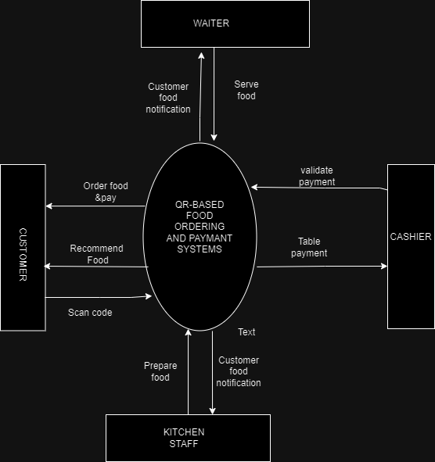

Figure 1: CONTEXT DIAGRAM

## **3.8.2 Use-case Diagram**

A use case diagram is a graphic representation of the interaction among the elements of a system.

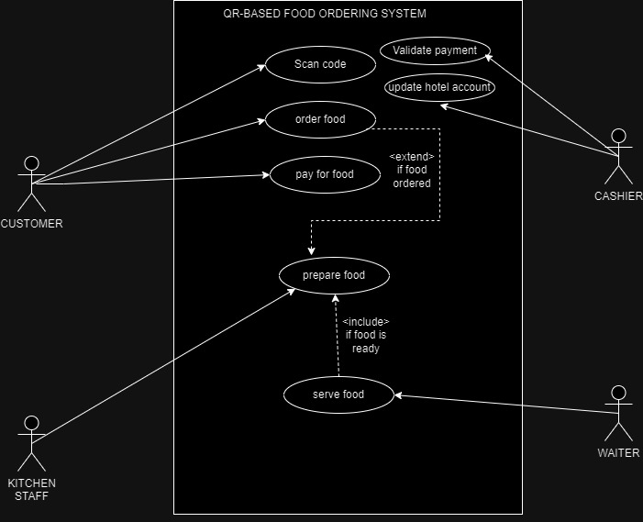

Figure 2:USE-CASE DIAGRAM

## **3.8.3 Dataflow Diagram**

A Data Flow Diagram (DFD) is a graphical representation of how data moves through a system It provides a visual overview of the system's data architecture and helps in understanding the interactions between various components. The figure below shows a dataflow diagram to be used for the system

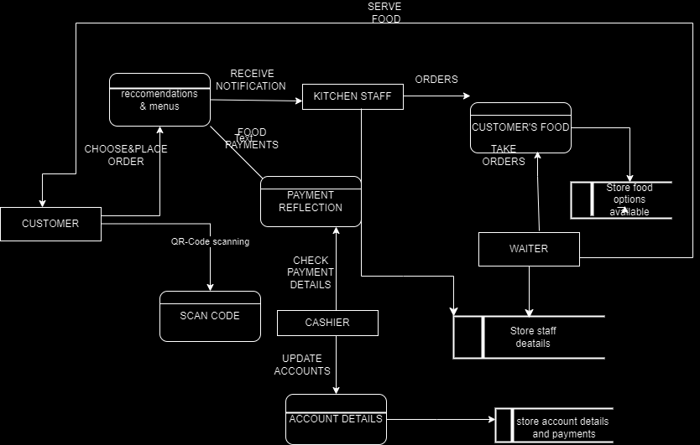

*Figure 3: DATA FLOW DIAGRAMS*

## **3.9 ETHICAL ISSUES AND ETHICAL CONSIDERATIONS**

Ensuring the ethical conduct of research was paramount to maintaining the integrity of the study and protecting the rights and well-being of participants. In this research on QR-based food ordering and payment systems, several ethical considerations and issues were carefully addressed.

Informed Consent: Prior to participating in the study, participants were provided with detailed information about the research objectives, procedures, potential risks, and benefits. They were required to provide informed consent voluntarily, with the understanding that they could withdraw from the study at any point without repercussions.

Anonymity and Confidentiality: All participant information was treated with strict confidentiality. Personal identifiers were removed from the collected data to ensure anonymity. Confidentiality extended to all aspects of the study, including data storage, analysis, and reporting.

Data Security: Adequate measures were implemented to secure and protect the collected data. Electronic data was stored on password-protected devices, and access was restricted to the research team. Physical records, if any, were stored in a secure location.

Respect for Participants: Participants were treated with respect and dignity throughout the research process. Any interaction with participants prioritized their well-being and comfort. Sensitivity was exercised, especially when discussing potentially sensitive topics related to technology use and personal experiences.

Minimization of Harm: Efforts were made to minimize any potential harm to participants. This included avoiding intrusive questioning and ensuring that survey questions and interview topics were phrased in a way that did not cause discomfort or distress.

# **REFERENCES**

1. Patel, Mayur Kumar. "Online Food Order System for Restaurants." Technical Library, Paper 219, 2015.
2. Archana Nikose, Aayush Hatwar, Akshata Nikose, Dhananjay Adikane, Khushi Gaharwar. "Cafeteria Food Ordering System using QR Code." International Journal of Scientific Research in Science, Engineering, and Technology (IJSRSET), Online ISSN: 2394-4099, Print ISSN: 2395-1990, Volume 10, Issue 2, pp. 157-163, March-April 2023. DOI: <https://doi.org/10.32628/IJSRSET2310212>
3. Jaiswal, A. S., Kulkarni, C. R., Patil, Y., Ponde, S., & Vaidya, R. B. (May 2023). “Smart Food Ordering System for Restaurants.” International Journal of Innovative Science and Research Technology, Volume 8, Issue 2, pp-1-3 February – 2023.https://www.researchgate.net/publication/370939827.

## **APPENDICES**

## **TABLE 1: WORKPLAN**

|  |  |  |  |
| --- | --- | --- | --- |
|  | SEPTEMBER-OCTOBER | OCTOBER-NOVEMBER | NOVEMBER- DECEMBER |
| **CHAPTER ONE** |  |  |  |
| **CHAPTER TWO** |  |  |  |
| **CHAPTER THREE** |  |  |  |

Table 1:WORKPLAN

## **TABLE 2: BUDGET**

|  |  |
| --- | --- |
| **ITEM** | **COST** |
| LAPTOP HP | 40000/= |
| **SOFTWARE TOOLS** | |
| DRAW.IO | FREE |
| MICROSOFT WORD | FREE |
| XAMMP SERVER:DATABASE | FREE |
| VISUAL STUDIO CODE | FREE |
| OPERATING SYSTEM :WINDOWS11 | PRE-INSTALLED |
| **TOTAL COST** | **40000/=** |

Table 2:BUDGET

## **INSTRUMENTS**

## QUESTIONNAIRRE

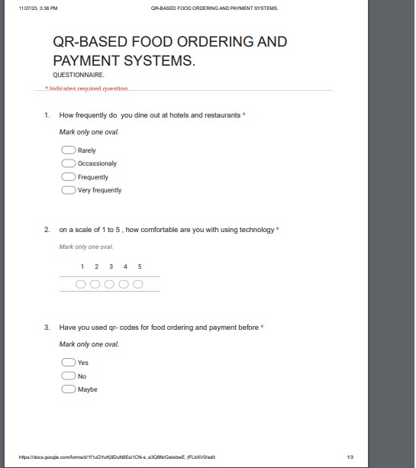

Figure 4:QUESTIONNAIRE

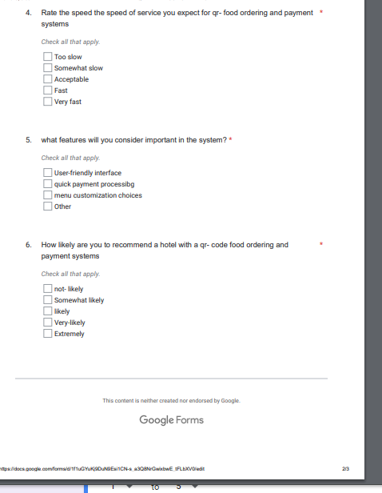

Figure 5:QUESTONNAIRE 2

## **INTERVIEWS**

1. Could you describe your ideal dining experience using a QR code-based food ordering and payment system in the past?
2. What challenges did you foresee in the widespread adoption of QR code technology in the food service industry?
3. How did you envision the role of QR codes evolving in the five years prior within the hospitality sector?
4. Could you share a personal anecdote or experience related to using technology for food ordering that left a lasting impression on you in the past?
5. In your opinion, what were the key considerations for restaurants or cafes planning to implement QR code-based systems in the past?
6. How did you feel about increased personalization in food recommendations based on your past ordering history through QR codes?
7. What role did you see QR codes playing in enhancing overall customer satisfaction in the food service industry in the past?
8. How could QR code technology contribute to making dining experiences more inclusive and accessible for a diverse range of customers in the past?
9. What were your thoughts on the balance between technological innovation and preserving traditional aspects of dining in the past?

Top of Form